Assessment Schedule – 2014
Chemistry: Demonstrate understanding of aspects of carbon chemistry (90932)
Evidence Statement
ONE | Evidence | Achievement | Merit | Excellence
(a)(i)  (ii)  (iii)  (iv)  (b)  (c) | Butane  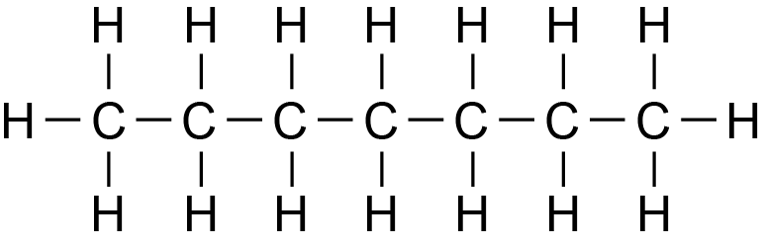  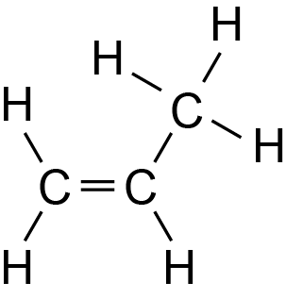  Ethanol  Covalent bonding occurs in organic compounds.  These organic compounds are made of carbon and hydrogen atoms, which are non-metal atoms. Non-metal atoms share their valence electrons to gain full outer shells, resulting in stable bonds. Sharing electrons in a bond is covalent bonding.  General formulae:  Alkanes (straight-chain) have the general formula C_{n}H_{2n+2} and alkenes have the general formula C_{n}H_{2n}.  Similarities and differences in chemical bonding:  In both alkanes and alkenes, the carbon and hydrogen atoms are covalently bonded to each other (could be from (b)). Alkanes are saturated hydrocarbon molecules, where each carbon atom has four single covalent bonds. Alkenes are unsaturated hydrocarbon molecules containing mostly single covalent bonds, but also a carbon–carbon double bond.  Chemical bonding linked to property and use:  Alkanes do not have a functional group, so they are generally chemically unreactive / readily combust (property). Alkanes are commonly used as fuels (use), because, while they are mostly unreactive, they do undergo combustion reactions since single bonds do not require as much energy to break. So a lot of energy is released as they combust.  The double bond in alkenes is a functional group and is easily broken, so alkenes are chemically reactive (property). Since alkenes are chemically reactive, they can also undergo other chemical reactions, and are therefore commonly used to make other organic molecules such as polymers (use) since the double bond easily breaks to form long chain. | - Any 3 correct from 1(a).  - Correctly identifies that alkanes and alkenes have covalent bonding.  - Correctly identifies the general formula for EITHER alkanes or alkenes.  - Identifies / names / draws the functional group of alkenes or the lack of a functional group in alkanes.  - Describes the reactivity of EITHER alkanes or alkenes. | - Explains that covalent bonds share electrons to complete their valence / outer shell or energy level / gain full outer shell.  - Explains similarities and differences in the bonding of alkanes and alkenes.  - Links chemical bonding to a property (e.g. reactivity) or use for BOTH alkanes and alkenes.  - Links chemical bonding to a property (e.g. reactivity), and then to a use for EITHER alkanes or alkenes. | - Links non-metal atoms to the sharing of valence electrons to complete a valence shell / gain full outer shell, resulting in a covalent bond.  - Explains similarities and differences in the bonding of alkanes and alkenes  AND  Links chemical bonding to a property (e.g. reactivity), and then to a use for BOTH alkanes and alkenes.

NØ | N1 | N2 | A3 | A4 | M5 | M6 | E7 | E8
No response or no relevant evidence | 1a | 2a | 3a | 4a | 2m | 3m | 2e with minor error or omission | 2e

TWO | Evidence | Achievement | Merit | Excellence
(a)  (b)  (c)  (d) | C₁₀H₂₂ → C₅H₁₂ + C₂H₄ + C₃H₆  Large organic molecules are inefficient fuels because they do not flow easily and are hard to ignite (not volatile enough – ie not easily made gaseous). They need to be cracked into smaller molecules that do burn more efficiently. Cracking also produces small alkenes, which are useful in making many other carbon compounds, including polymers.  Ethane is an alkane containing only single (covalent) bonds.  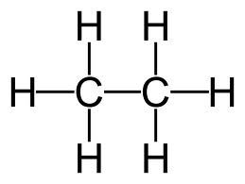  The single bonds are stable, so ethane does not react to form the long chains of a polymer.  Ethene is an alkene containing a double (covalent) bond, which acts as a functional group / is reactive / is easily broken, allowing ethene to act as a monomer.  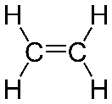  (In high temperatures and high pressures, with a catalyst) the double bond breaks in the ethene molecules, allowing the different molecules to join together with single covalent bonds forming a long chain called a polymer. Ethene makes polyethene.  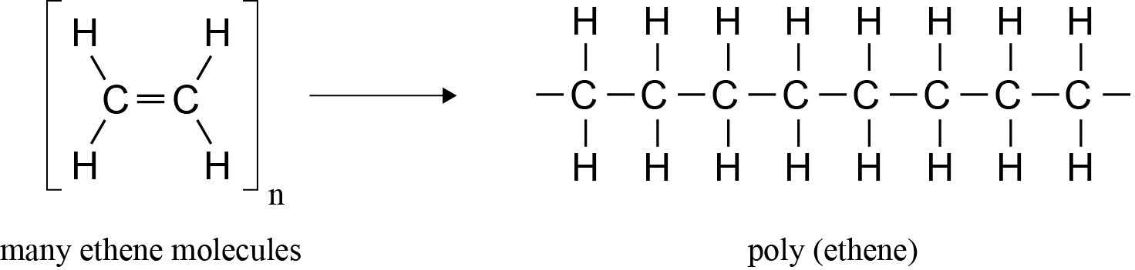  Chemical structure and bonding:  They are both made up of long chains of carbon atoms bonded together with single covalent bonds.  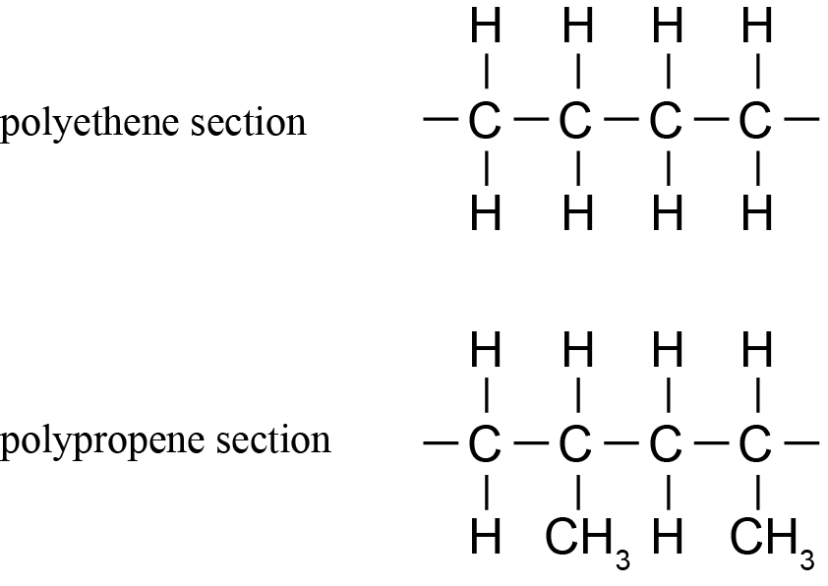  Chemical reactivity:  Since neither has a functional group / only have single covalent bonds, they are both unreactive (non-biodegradable), which means they will not break down in the oceans, so polyethene and polypropene float on the ocean’s surface. | - Two product formulae correct.  - Identifies that large organic molecules do not make good fuels / cannot be used to make polymers.  - Identifies ethane has all single bonds (saturated) and ethene has a double bond (unsaturated). Evidence could be from diagrams.  - Describes or draws the chemical structure / bonding of both polymers.  OR  Identifies that neither polymer has a functional group.  OR  States that the polymers are non-biodegradable / unreactive / do not naturally break down. | - Equation is completed correctly.  - Explains why large organic molecules do not make good fuels / cannot be used to make polymers (no C=C bond).  - Explains why ethane cannot form polymers.  OR  Explains why ethene can form polymers.  - Explains why the polymers are non-biodegradable / unreactive / do not naturally break down. | - Links explanation of why large organic molecules do not make good fuels and anexplanation of how cracking makes smaller molecules that are more efficient fuels / useful in making other compounds, e.g. alkenes make polymers, ethene makes ethanol for solvent use, etc.  - Links the explanation for why ethane cannot form polymers to the explanation for why ethene can form polymers. (Conditions for polymerisation are not required, neither are diagrams.)  - Links explanation of why the polymers are non-biodegradable / unreactive / do not naturally break down, resulting in the floating islands of plastic in the ocean. (Diagrams not required).

NØ | N1 | N2 | A3 | A4 | M5 | M6 | E7 | E8
No response or no relevant evidence | 1a | 2a | 3a | 4a | 2m | 3m | 2e | 3e

THREE | Evidence | Achievement | Merit | Excellence
(a)  (b)  (c) | The boiling point of a chemical is the temperature at which the chemical changes from the liquid state to the gaseous state.  (Technically the boiling point is the temperature at which the vapour pressure of a liquid equals the external pressure surrounding the liquid. Therefore, the boiling point of a liquid depends on atmospheric pressure. The boiling point becomes lower as the external pressure is reduced. However, this is beyond what we would reasonably expect at Level 1.)  Describe the trend:  As the number of carbon atoms increases in the alkane family, the boiling point increases.  Explain the trend:  As the number of carbon atoms increases, the molecules also increase in size, resulting in a larger / stronger attractive force between the molecules. This results in more heat energy being required to separate the molecules to allow them to become gases.  Structure and chemical bonding:  Ethane and ethanol both contain 2C and 6H atoms, but ethanol also has an additional oxygen atom which forms a hydroxyl group, –OH.  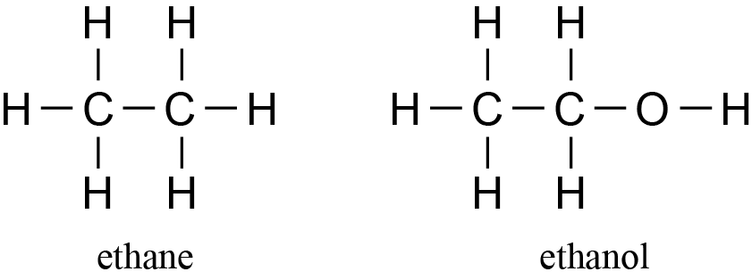  Both ethane and ethanol contain single covalent bonds.  Link to solubility:  Ethane is not soluble in water as there are no attractions between ethane and water. However, ethanol is an alcohol that is soluble in water because (they both contain –OH groups) they are attracted to each other.  Link to boiling point:  Ethane has a lower boiling point than ethanol because it has weaker attractions between the molecules, so does not need as much heat energy (do not accept temperature) to boil. | - Defines the term boiling point as the temperature at which a liquid becomes a gas.  - States that the boiling points increase as the number of carbon atoms increases.  - Accurately describes or draws the chemical structure of ethane and ethanol.  - States ethanol has strong attractions between molecules / ethane has weak attractions between molecules.  OR  States ethanol is attracted to water / ethane is not attracted to water. | - Explains that the larger the molecule, the larger / stronger the attractive force between the molecules.  OR  Explains that more heat energy is required to separate the molecules the larger they get.  OR  Explains that as the number of carbon atoms increases, the larger / stronger the attractive force between molecules.  - Explains solubility in terms of chemical structure and lack of attractions / attractions between ethane and water, and ethanol and water, respectively.  - Explains the boiling point in terms of chemical structure and the attractions between ethane and ethanol molecules.  - Explains BOTH physical properties for either ethane or ethanol. (May not have compared and contrasted). | - Links the number of C atoms / size of molecule to the relative strength of the forces between the molecules, the energy required to separate the molecules, and their boiling points.  - Compares and contrasts the bonding and structure of each compound to each other to allow explanations for the differences in solubility and boiling points.  (Must compare and contrast to get Excellence – not just writing explanations).

NØ | N1 | N2 | A3 | A4 | M5 | M6 | E7 | E8
No response or no relevant evidence | 1a | 2a | 3a | 4a | 2m | 3m | 2e  minor error / omission allowed. | 2e

FOUR | Evidence | Achievement | Merit | Excellence
(a)  (b)(i)  (ii)  (c) | 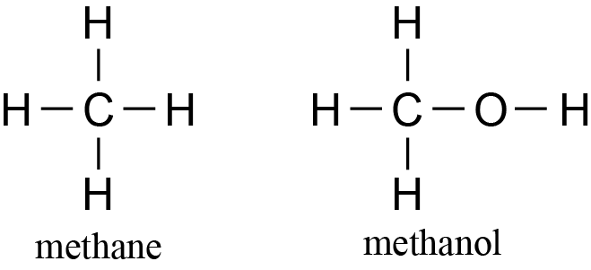  CH₄ + H₂O → CO + 3H₂  Ni  (Catalysts and heat are not required in the equations).  CO + 2H₂ → CH₃OH  250°C  Cu–Zn  Describe combustion reactions:  Methanol undergoes complete combustion (since it burns with an almost invisible flame) to produce carbon dioxide gas and water vapour.  CH₃OH(l) + 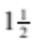O₂(g) → CO₂(g) + 2H₂O(g)  Methane undergoes incomplete combustion (since it burns with an orange, probably sooty flame) to produce carbon (soot), carbon monoxide, (carbon dioxide), and water vapour.  2CH₄(g) + 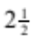O₂(g) → C(s) + CO(g) + 4H₂O(g)  (or any appropriate variation of incomplete combustion).  Effects of combustion:  Complete combustion of methanol produces carbon dioxide gas and water vapour, both of which are greenhouse gases, so they contribute to the greenhouse effect / global warming.  Incomplete combustion in methane, as well as producing carbon dioxide and water vapour, can also produce carbon particles, which can cause asthma and other respiratory problems in people, visual pollution in the environment, eg blackening of limestone walls and monuments, and slow photosynthesis by coating leaves. It also produces carbon monoxide, which is toxic to humans, and can, in extreme situations, result in death since it replaces oxygen in the blood supply. | - Both structures correct.  - Most formulae correct in (i) and (ii), i.e. one incorrect formula allowed in each of (i) and (ii).  - Correctly identifies methanol as the substance undergoing complete and methane undergoing incomplete combustion.  - Identifies products of complete and incomplete combustion correctly.  - Describes one effect of either type of combustion on the environment or human health. | - All formulae correct but equations not balanced.  - Links methanol and methane to the correct type of combustion and products  OR  Relates one type of combustion to TWO effects on the environment or human health.  OR  Relates each type of combustion to ONE effect on the environment or human health (TWO effects total).  - Writes ONE unbalanced symbol equation, with all formulae correct. | - Both equations correct in (b).  (States, catalysts and heat are not required in balanced equations).  - Links methanol and methane to the correct type of combustion and products.  AND  Relates each type of combustion to ONE effect on the environment or human health (TWO effects total).  - Writes ONE balanced symbol equation from (c).  (States are not required).

NØ | N1 | N2 | A3 | A4 | M5 | M6 | E7 | E8
No response or no relevant evidence | 1a | 2a | 3a | 4a | 2m | 3m | Excellence level explanation plus balanced equation(s) from either (b) OR (c). | Excellence level explanation plus balanced equations from (b) AND (c)

Cut Scores
 | Not Achieved | Achievement | Achievement with Merit | Achievement with Excellence
Score range | 0 – 10 | 11 – 17 | 18 – 24 | 25 – 32

